1. Install net_test.apk.
2. First, select the Asia region and tap "Connect".
- Wait at least 20 seconds; once the red log shown in the image appears, wait a few more seconds before taking a screenshot. If it does not appear, wait a bit longer.
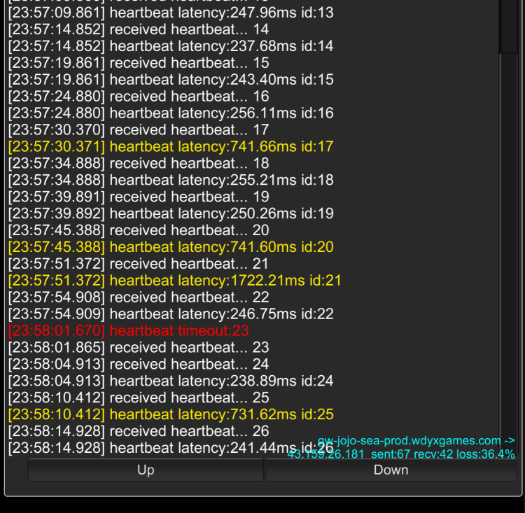
- Tap to switch.
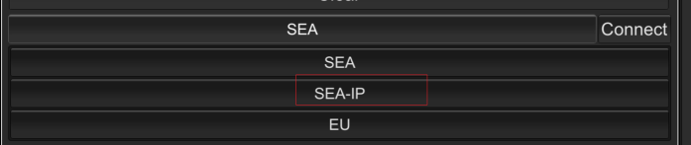
4. Tap "Connect".
5. Wait at least 20 seconds; once the red log shown in the image appears, wait a few more seconds before taking a screenshot.
6.Provide all screenshots to customer service.

